Chapter 3, Solution 90

Calculate v_{s} for the transistor in Fig. 3.126, given that v_{o} = 4 V, β = 150, V_{BE} = 0.7V.

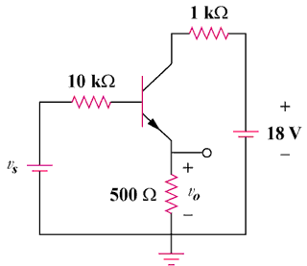

Figure 3.126
For Prob. 3.90.

Solution
+
V₀
–

500 Ω
-

+

18V
-

+

v_{s}

i₁

i₂
+
V_{CE}
–

+
V_{BE}
–

I_{B}

I_{E}

10 kΩ

1 kΩ

For loop 1, -v_{s} + 10k(I_{B}) + V_{BE} + I_{E} (500) = 0 = -v_{s} + 0.7 + 10,000I_{B} + 500(1 + β)I_{B}

which leads to v_{s} + 0.7 = 10,000I_{B} + 500(151)I_{B} = 85,500I_{B}

But, v₀ = 500I_{E} = 500x151I_{B} = 4 which leads to I_{B} = 5.298x10⁻⁵

Therefore, v_{s} = 0.7 + 85,500I_{B} = 5.23 volts

